**EXPERIMENT 3**

**Aim :**

Build Infrastructure Mode in Wireless Networking.

**Theory :**

The IEEE 802.11 has two basic modes of operation: Infrastructure and Ad-Hoc mode. In ad-hoc mode, mobile units transmit directly peer-to-peer. In infrastructure mode, mobile units communicate through a wireless access point (WAP) that serves as a bridge to other networks (such as the Internet or a local area network).

**Infrastructure Mode**

Wireless networks running in infrastructure mode use one or more WAPs to connect the wireless network nodes centrally. This configuration is similar to the star topology of a wired network. Setting up an infrastructure mode network requires at least one wireless access point (AP) and that the AP and all the clients be configured to use the same network name (SSID). The access point is cabled to the wired network to allow wireless clients access to resources like the internet or printers. Additional APs can be joined to this network to increase the reach of the infrastructure and support more wireless clients.

**Ad-Hoc vs Infrastructure Mode**

* Compared to ad-hoc, infrastructure mode offers the advantage of scale, centralized security management, and improved reach. Wireless devices can connect to resources on a wired LAN, which is common business settings.
* Disadvantage of infrastructure mode is simply the additional cost to purchase AP hardware. Ad-hoc networks connect to devices in a peer-to-peer manner, so all that's needed is the device themselves.
* Infrastructure mode is typical for long-lasting, more permanent implementations of a network. Homes, schools, and businesses do not usually spring for P2P connections used in ad-hoc mode because they're just far too decentralized to make sense in those situations.
* Ad-hoc networks are usually seen in short-lived moments where some devices need to share files but they're too far from a network to make it work. Or, maybe a small operating room in a hospital can configure an ad-hoc network for some of those wireless devices to communicate with each other.
* However, if you just need a few devices to communicate with one another, an ad-hoc network is fine. Don't add too many though, because one limitation of ad-hoc networks is that at some point the hardware just isn't fit for all of that traffic demand, which is when infrastructure mode is necessary.



**Configure Broadband Access Router :**

**1.** Access Setup Page –

1. Type 192.168.0.1/192.168.1.1 in browser address bar and press enter.
2. Enter username and password provided or check at the back of the router for login credentials. Click on login to access the setup page.

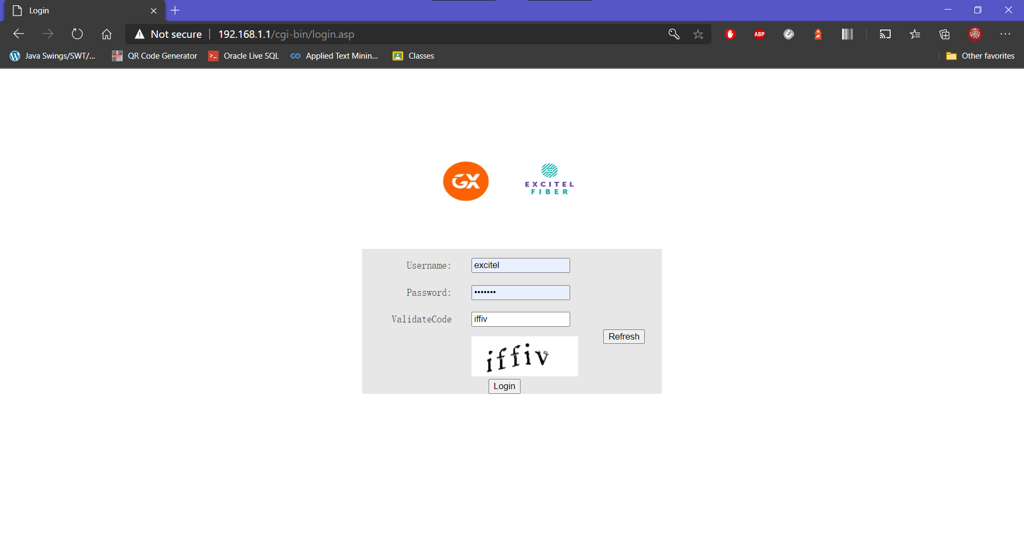

**2.** Click on Net/Manage or something like it depending on your router –

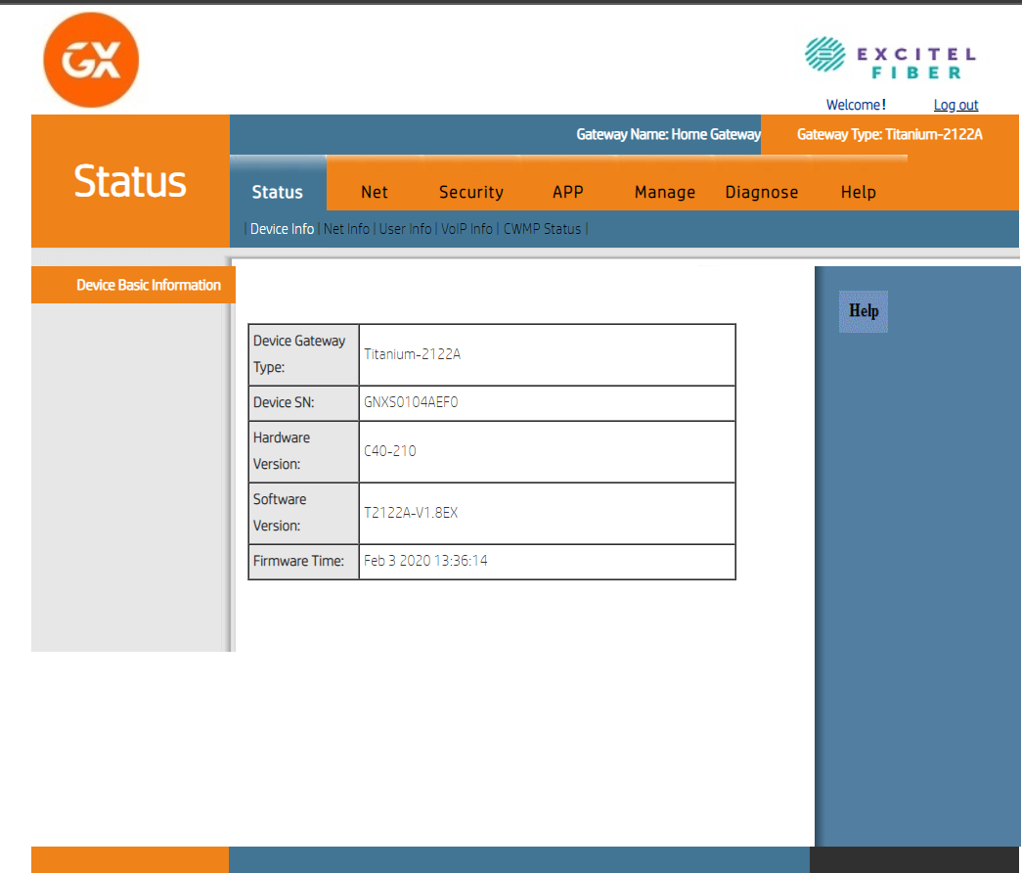

**3.** Select Internet Connection Type –

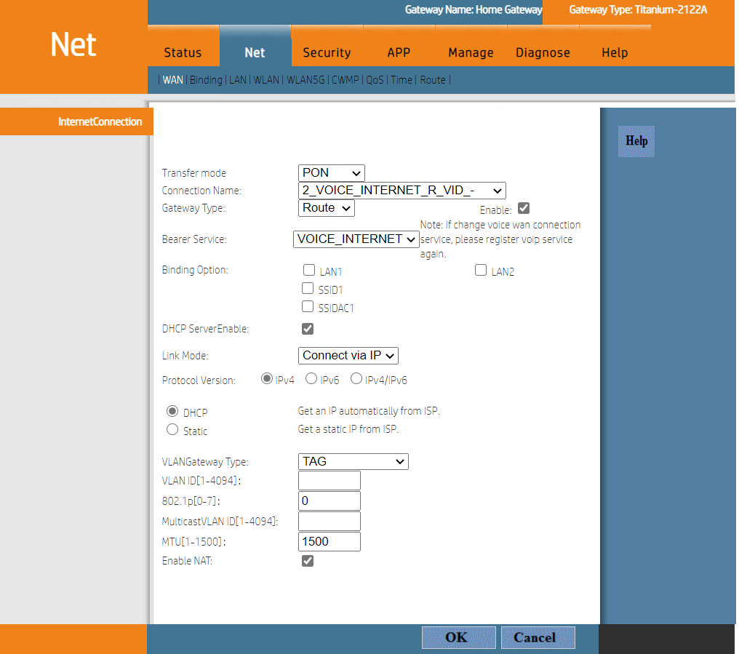

**Configuration Details for each of the Internet Connection Types is given below :**

**1.** Configure D-Link Router for Cable Internet Connection –

To setup your router with cable internet, select the option Dynamic IP (DHCP).

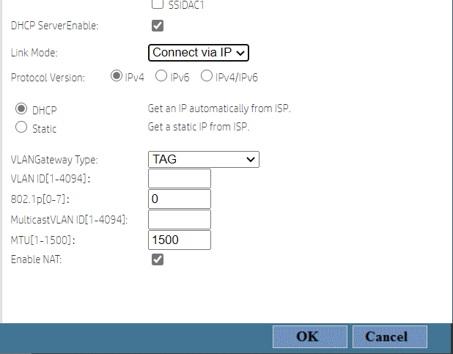

**2.** Configure D-Link Router with Static IP –

Enter the full IP Address details provided by your Internet Service Provider including Subnet Mask, Default Gateway, DNS Servers, etc.

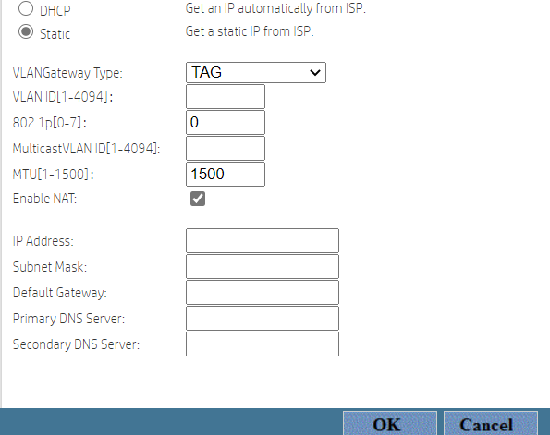

**Configure Wireless and Security :**

Right after configuring internet access on router, you need to configure the wirelesssettings if you want to use it. Latest wireless routers support both 2.4GHz and 5GHzfrequencies in order to extend its support to 802.11a, 802.11b, 802.11n and 802.11g wirelessstandards. 802.11n supports both 2.4GHz and 5GHz whereas 802.11a supports 5GHz only.802.11b and 802.11g work in 2.4GHz. Here are the manual steps to configure wireless andsecurity on router.

**1.** Login into your router setup page using your credentials.

**2.** Click on Wireless (WLAN) Settings tab –

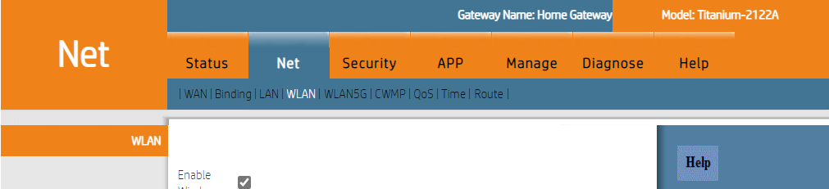

**3. WLAN for 2.4GHz Devices (**802.11n, 11g and 11b**) –**

1. Click on Enable Wireless and Select 802.11 mode (2.4GHz).

You can select one of the following 802.11 modes :

* 802.11b Only
* 802.11g Only
* 802.11a Only
* Mixed 802.11g and 802.11b
* Mixed 802.11n and 802.11g
* Mixed 802.11n, 11g, 11b

1. Check on Enable Auto Channel Scan.
2. Now Wireless Router will automatically pick the channel with least interference.
3. Wireless Network Name – Here you can write the name of your wireless network (SSID). SSID can be up to 32 characters and it is case sensitive.
4. Select Channel Width – 20/40 MHz if you are using both 802.11n and non 802.11n devices. If you are not using 802.11n devices you can select 20MHz.
5. Visibility of SSID – If you do not want to show your SSID, you can check the option Invisible.

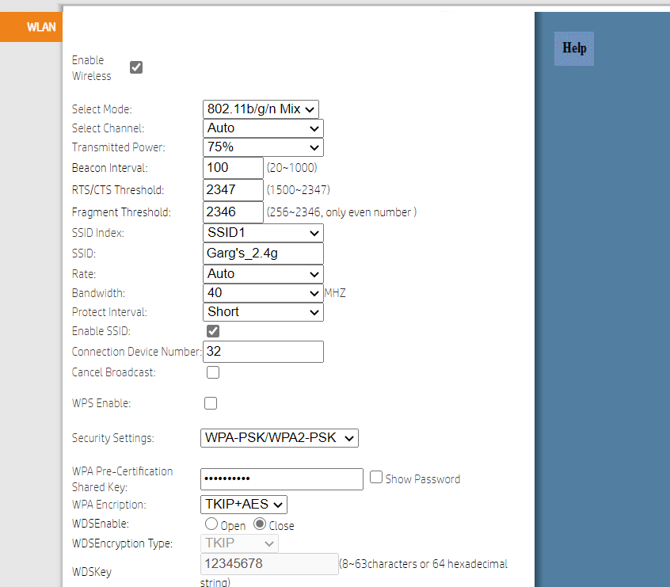

**4. WLAN for 5GHz Devices (**802.11n and 11a**) –**

Go to the WLAN5G tab and follow the same steps as mentioned above for 2.4GHz Devices.

